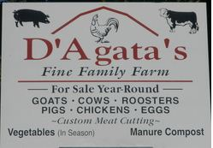
Custom Beef, Hog & Wild Game Processing
1448 North Grand St (Rt 187)
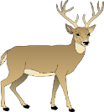
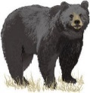
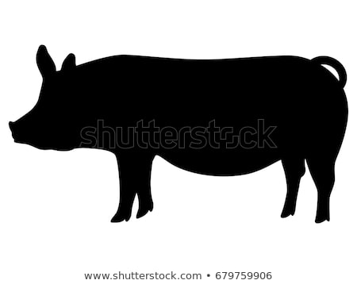West Suffield CT 06093
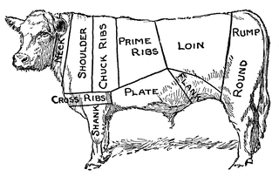
860-668-6906 860-670-2311
www.dagatas.com
----------------------------------------------------------------------------------
Beef, Hog & Goat Processing

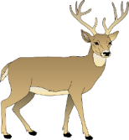
Deer Processing

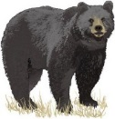
Bear Processing
---------------------------------------------------------------------------------- By Bruce D’Agata
D’Agata’s Fine Family Farm  1448 North Grand St (Rt 187) West Suffield CT 06093  860-668-6906 860-670-2311 www.dagatas.com  We custom process  ALL animals.  25 years experience. Give us a call.  You won’t be disappointed. | Prices  ​Deer & Bear Processing: $100.00  Cape: $35.00  European Mount: $250.00  Sausage: $2.00/lb  860-670-2311  Drop off and pickup, Bring cooler at pickup  Tags required

