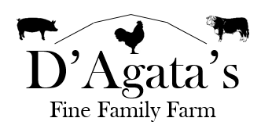
Chicken:
Sold out
Whole Chicken: $4.99/lb
Sold out
Breast: $5.10/lb
Wings: $3.89/lb
Sold out
Legs & Thighs: $3.00/lb

Pork:
Loin Roast: $5.67/lb
Bone-in Pork Chops: $5.50/lb
Boneless Pork Chops: $5.67/lb
Pork Tenderloin: $9.50/lb
Bratwurst: $5.50/lb
Sausage (loose): $5.00/lb
Hot Italian
Sweet Italian
Breakfast
Maple

Eggs: $4.00 / Dozen

Beef:
Top Round Steak: $7.50/lb
Top Round Roast: $7.00/lb
Stew Meat: $6.00/lb
Hamburger: $5.50/lb

