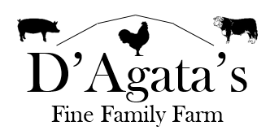

Pork:
Loin Roast: $5.67/lb
Bone-in Pork Chops: $5.50/lb
Boneless Pork Chops: $5.67/lb
Pork Tenderloin: $9.50/lb
Bacon: $8.90/lb
Sausage: $5.00/lb
Hot Italian
Sweet Italian
Maple
Breakfast
Bratwurst: $5.50/lb

Beef:
Top Round Steak: $7.50/lb
Top Round Roast: $7.00/lb
Stew Meat: $6.00/lb
Hamburger: $5.50/lb
Hamburger w/ bacon: $6.50/lb

Chicken:
Whole Roasting Chicken:
$3.20/lb

